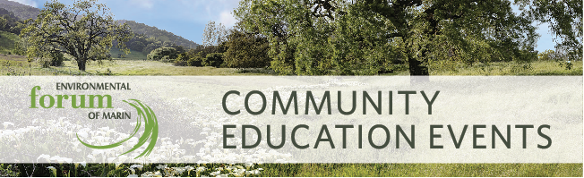

The "Great Divide": Can We Work Together for a Healthy Environment?

Monday November 19, 2018, 6:30-8:30pm, Corte Madera Community Center

Speakers Bios:

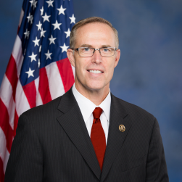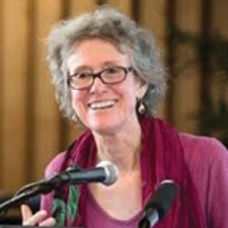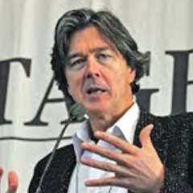
Jared Huffman Arlie Hochschild Mark Hertsgaard

Jared Huffman, US Representative (CA 2nd District) is an ardent protector of the environment and has worked to pass effective legislation for both California and the nation. He created the podcast, Off the Cuff with Jared Huffman, to promote productive and open dialogue across a spectrum of constituents on some of today’s biggest challenges. Huffman will introduce this program by sharing some of his experiences “bridging the divide” and the importance of doing so.

Arlie Hochschild, Professor Emerita of Sociology at UC Berkeley and author of Strangers in Their Own Land: Anger and Mourning on the American Right, spent much of five years interviewing Tea Party enthusiasts in Louisiana, many of whom were impacted by severe environmental degradation, to learn their “deep stories” and attempt to “cross the empathy divide”. She will present the findings of her book and views on why some people often seem to vote against their best interests when it comes to the environment.

Mark Hertsgaard, Environmental Correspondent for The Nation and author of Hot: Living Through the Next Fifty Years on Earth, has spent much of his career focused on climate change and the politics that influence environmental decision-making. Following Professor Hochschild’s presentation, Hertsgaard will host a fireside chat with her to delve into some of the complex issues around “The Great Divide”.

Information and Registration at www.MarinEFM.org

